Department of education and science of Russian Federation
Russian State University for the Humanities

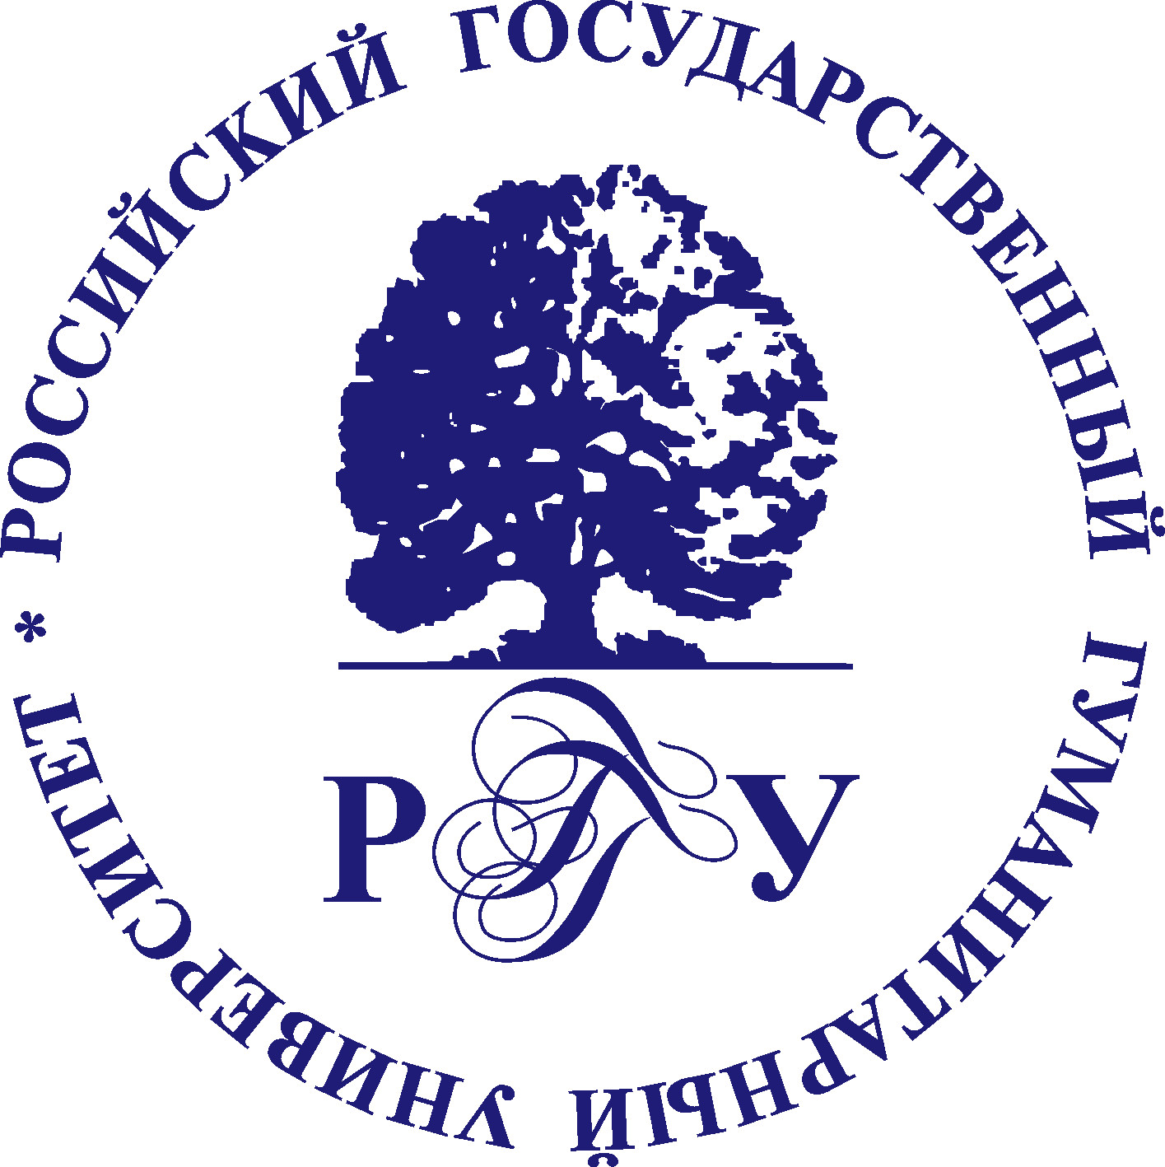

Faculty of history, political science and right, together with Knorozov Mesoamerican Center of Russian State University for the Humanities organize work of international scientific conference
«Walls and Bridges»:
Interdisciplinary approaches in historical researches
June, 2012

On the modern stage of development of historical science an idea speaks out all more frequent to give up the traditional division of research spheres of history and social sciences. Thus the necessity of their foremost theoretic-methodological rapprochement is realized all more distinct.
The aim of the conference is to form a possible full and objective idea about Russian historical science interdisciplinary links formation and development, forming modern scientific perspectives in various research directions (study of man or public forces in the epoch context)
Work of home scientific pedagogical collectives and individual researchers should be studied in broad context of the world historical science development in the focus of all humanitarian disciplines: history, sociology, psychology, linguistics and their subdivisions.
Within the conference frame following topics are supposed to be discussed:
Methods of social science and humanities applied in history: theoretical issues of discipline cooperation and co-influence (in between history, linguistics, psychology, sociology; sub-discipline problems within historical sociology, social history, historical psychology, etc.
Interdisciplinary approaches experience in historical research practice of the XX century:
- the role and significance of certain institutional centers, which started interdisciplinary approaches;
- ways, methods, creative laboratories of individual researchers;
- techniques of interdisciplinary ideas development in the soviet historical science, boundaries and legitimacy of some steady stereotypes in the soviet science perception;
- positioning of institutes and individual researchers of interdisciplinary issues during the “perestroika” and post-soviet Russia period;
- the role and significance of western interdisciplinary innovations influence on Russian research practice.
Modern Interdisciplinary research practice: the ideas of J. V. Knorozov and B. F. Porshnev in ancient civilizations and archaic societies studies; anthropo-systematical approach, social, cultural, political anthropological practice.
Historians, sociologists, psychologists, - those who touch historical issues in their research, - are welcome to participate in the conference.
Requests on the conference participation and texts to be published are accepted up to March, 1st, 2012 г. by e-mail: conference2012@yandex.ru:
(Please, mark «Full name__Conference» in the line «theme»).
The participant request is filled in accordance with the applied form. You are welcome to e-mail participation questions to the organizational committee secretary Eugenia Dolgova (the given e-mal address)
The article text form:
Text format: doc MS Word 00-03, text size - up to 0,5 sheet (up to 20 thousand printed sign), font – Times New Roman, size 14 (for foot-notes – 12), single spacing, all page sides - 2,5 см. First line indention - 1,25, automatically set. The text should be edited. Foot-notes should be automatic end-capping.
The article should be provided with annotation (it will be published together with the article). The annotation note should include: 1) author name, article title; 2) article perspective; 3) issue field features; list of main problems, mentioned in Your paper; 4) keywords (not more than 10 words). The annotation size should be not more than 700-800 signs (with spacing).
Please, do not print the title in the mode Caps Lock, do not use the stiles MS Word, do not set up line indentions by tabulation or gap button and do not use special fonts. Foot-notes should be end-capping, in the automatic mode.
All the participants will get individual e-mail invitation letter and the preliminary program from the organizing committee not later than May, 15th, 2012.
The organizing committee reserves the right to select participation requests. Articles are not reviewed. The organizing committee reserves the right not to enter into correspondence with the authors.
You will get additional information about the exact dates of the conference.
The conference participant’s fare is not paid. The organizing committee gives assistance in reserving hotels in Moscow.

